Python Commands:

**Libraries Used-**

1. Schedule
2. Time
3. BeautifulSoup4 (bs4)
4. Request
5. Urlopen
6. Csv
7. Json

**Process: -**

1. Web scrapping
   1. BeautifulSoup4
2. Add to text
   1. Request
3. Delete Duplicate
   1. CSV
4. Convert CSV to Json
   1. CSV
   2. JSON
5. Enable Scheduler
   1. Schedule

**Description: -**

* In python it will be recommended to import libraries in first phase of the code.

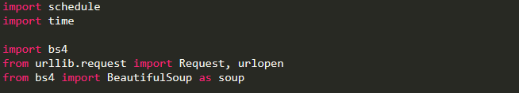

* Next, we initialize a file called Bruteforce.txt and provide it with the headers.

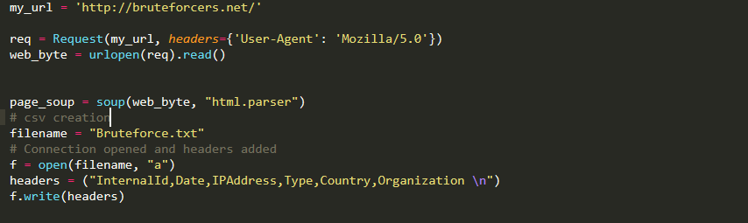

* Now web scrapping of bruteforcers.net begins and append in the list column by column according to the headers provided initially.

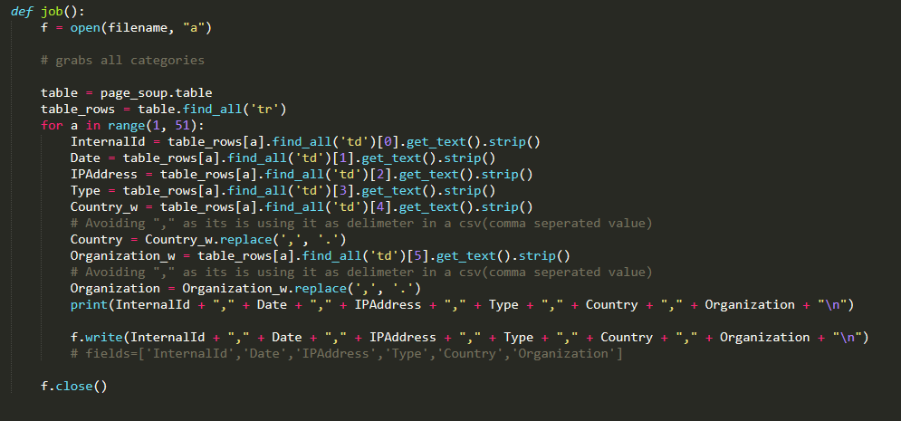

* Now we match currently scrapped data with previously scrapped stored data so that we can update the content dynamically without repetition and store it in a csv.

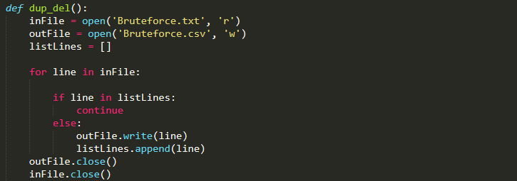

* Now we convert the csv stored in a previous step to json as DNIF platform requires json file.

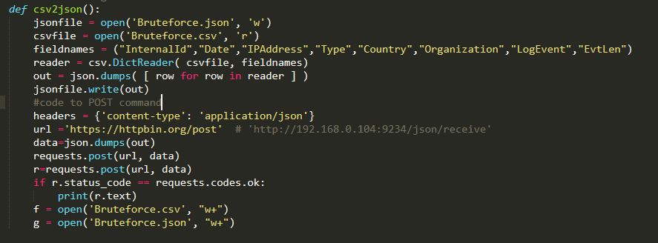

* Now we initialize the scheduler so that we get updated data every 5 seconds and delete and update csv every 11 seconds.



* Repeat above code until python is interrupted

